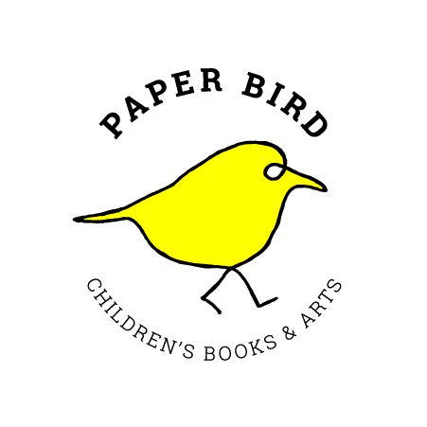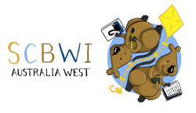

Paper Bird Fellowship

Application Form

Name:
Email:
Phone:
Website/Facebook/Instagram:

I’m a member of: CBCA(WA) SCBWI Australia West IBBY other

I identify primarily as:
writer illustrator author-illustrator

Previous books or published work: (3 samples attached)

I’m currently working on: picture book novel other

For: Ages 0-3 3-5 5-8 8-12 12-14 14+
Genre (if applicable):
Medium (if applicable):

I hope to achieve …………………..with my time as a PB Fellow.

Completion of a manuscript? Progress towards publication? Hone my practice and try new ideas? Other?

As a PB Fellow, I would share my practice by…………………..
Presenting to groups of kids? Presenting to adults? Conducting a workshop based on my practice? Other

